PreparationofPapersforAfrica Journal of Physical Sciences

SCOPE

The scope of the journal would encompass disciplines within the Basic and Applied Sciences namely; Chemistry, Geology, Mathematics, Meteorology, Physical Geography and Physics. The journal would look at issues of Research and Development, and Technology and Innovation in addition to basic and applied sciences research.

TYPE OF CONTRIBUTIONS

Thetypes of contributions solicited areoriginal researchwork andreviewpapers.

SUBMISSIONOFARTICLES

TheoriginalmanuscriptistobewrittenandsubmittedinMicrosoftWord.Itisrecommendedthatmanuscriptshouldnotexceed5,000words,andfootnotesshouldbeavoided.See the reference template below. Submit your article to ajps@uonbi.ac.ke

The synergy between the Comprehensive Nuclear Test-Ban Treaty Organization (CTBTO) and the Kenya National Data Centre (KE-NDC)

MULWA Josphat Kyalo^{1,a,*},andOpiyo-Akech Norbert^{1,b}

1University of Nairobi, Department of Geology, P.O. Box 30197-00100, Nairobi,

ajkmulwa@uonbi.ac.ke*,bopiyo-akech@uonbi.ac.ke

ARTICLE INFO |  | ABSTRACT
Article History:  Available online 31 July 2014 |  | The March 24, 2019 earthquake in the Chyulu hills area was one of the strongest earthquakes (mb 4.2) to occur in Kenya during the year 2019. Chyulu hills is an off-rift volcano located in the southwestern Kenya and has been seismically active. As part of the Kenya National Data Centre (KE-NDC) efforts to complement the Comprehensive Nuclear Test-Ban Treaty Organization (CTBTO) to monitor compliance of the Comprehensive Nuclear Test-Ban Treaty (CTBT) by member states, we used seismic and infrasound data to evaluate the nature and characteristics of the Chyulu hills seismic event (whether anthropogenic or natural). In our analyses, we used body wave seismic phases (Pn, Sn), surface wave seismic phase (Lg) as well as the focal depth. In addition, we also used propagation velocity of the acoustic signal detected by the infrasound station I32KE. Our results show that the seismic event is a natural earthquake by virtue of its depth of focus i.e. 9.1 km. The infrasound station to source azimuth of 139.63º further complements the epicentral location of the seismic event in the southwestern Kenya near Chyulu hills.  ©2015 Africa Journal of Physical Sciences (AJPS). All rights reserved.  ISSN 2313-3317
Keywords:
Chyulu hills
Seismic event
Characterization
Seismic phases
Focal depth

1. Introduction

The Comprehensive Nuclear Test-Ban Treaty (CTBT) is an international and multilateral treaty that bans all nuclear explosions, for both civilian and military purposes, in all environments [1]. The CTBT was adopted by the United Nations General Assembly on 10th September 1996 in New York, and opened for signature on 24th September 1996. On the 19th November 1996, during the first meeting of the States Signatories to the CTBT, they voted to adopt a resolution establishing the Preparatory Commission for the Comprehensive Nuclear-Test Ban Treaty Organization (CTBTO Prep Comm), herein referred to as the Organization or simply CTBTO. The objective of the Organization is to prepare for the entry into force (EIF) of the Treaty and its role is to achieve the object and purpose of the treaty, to ensure the implementation of its provisions, including those for international verification of compliance with it, and to provide a forum for consultations and cooperation among States Parties [1].
The Organization stipulates the creation of a National Data Centre (NDC) within the member states. The NDC is expected to have the capacity to receive, process, analyse and interpret data from any of the CTBTO’s 337-facility International Monitoring System (IMS), as well as receiving additional raw and processed data (i.e. IDC Products) from the Organization’s International Data Centre (IDC) in Vienna, Austria [2]. The IMS is comprised of four technologies:- seismic, hydroacoustic, infrasound, and radionuclide monitoring each with its specific objective in the verification regime of the CTBT [1,2]. The sole responsibility of the NDC is to advise the government of any cases of Treaty violations, in addition to using the data for training, research, civil and scientific applications. Kenya being a member state of the CTBTO signed and ratified the treaty on November 14, 1996 and November 30, 2000 respectively. Kenya therefore hosts a National Data Centre (KE-NDC) domiciled in the Department of Geology, University of Nairobi.
This paper presents the methods of International Monitoring System (IMS) facilities data access at the Kenya National Data Centre from the CTBTO’s International Data Centre (IDC), as well as results of seismic and infrasound waveform data analysis, event location and characterization at KE-NDC. The term event is herein used ambiguously as it may be generated by man-made (anthropogenic) or natural sources.

2. Materials and Methods

In accordance with the requirements of the CTBTO, Kenya being a member state of the CTBTO hosts a National Data Centre (NDC) domiciled in the Department of Geology, University of Nairobi. At the Kenyan NDC waveform data from the CTBTO’s 337-facility International Monitoring System (IMS) is received, processed, analysed and interpreted so as to determine the nature and characteristics of the events (whether natural or man-made) generating such waveform data. The sole responsibilities of the Kenyan NDC include: - (i) receiving, processing, analyzing and interpreting IMS data and IDC products and verifying the nature of the events; (ii) advising the government, through the National Authority, i.e. National Commission for Science Technology and Innovation (NACOSTI), of any cases of treaty violations; and (iii) using IMS data and IDC products for training, research, civil and scientific applications. The civil and scientific applications of IMS data and IDC products include among others:- monitoring and characterization of earthquakes, tsunamis, landslides, terrestrial and underwater volcanic eruptions, studies on the earth’s internal structure, monitoring of sea/ocean temperature and signs of global warming, ocean swell research, whale populations, atmospheric and meteorological studies, detection of meteor impacts in the atmosphere, radiation monitoring on possible radioactive releases and studies on natural radioactivity [2].
IMS data and IDC products are accessed at the Kenyan NDC from CTBTO through any of four data access methods [2]. These methods include: - (i) IDC Secure Web Portal (an interactive graphical web-based server interface that allows the user to browse, view, download and retrieve IMS data and IDC products online using the CTBTO’s secure web portal, (ii) Requests (on demand one-time requests of IMS data and IDC products of special interest submitted either via email or through a command line client software). Data and products access using this method requires a preformatted text message in IMS2.0 format [2]. Email requests are also known as automated data request manager (AutoDRM) requests, (iii) Subscription (standing requests of IMS data and IDC products forwarded continuously once available at IDC until cancelled by the subscriber). Subscriptions also require a preformatted text message in IMS2.0 format [2], (iv) IDC External Database Service or Virtual Data Messaging System (VDMS) (a timely and direct data access method to replicas of the CTBTO/IDC operational and archival databases and parameters. This method requires the use of SQL statements. Access right(s) is/are required for all the four data and products access methods. Such rights are given by the CTBTO on recommendation by the CTBTO’s Point of Contact (PoC) at the National Authority.
In order to demonstrate the contribution of the Kenyan NDC in fulfilling the mandate and objectives of the CTBTO, we considered an event which occurred on March 24, 2019 in the southwestern part of Kenya in the vicinity of Chyulu hills. We requested two sets of IMS waveform data from the International Data Centre (IDC) i.e. seismic and infrasound data. Whereas seismic technology monitors propagation of seismic waves in the earth’s subsurface, infrasound technology monitors low frequency acoustic waves either through the atmosphere or in the subsurface. The waveform data were processed, analyzed and interpreted in order to characterize and locate this event. Analysis of the infrasound waveform data was used to supplement our characterization of the March 24, 2019 event and to provide additional information in regard to the epicentral location on the basis of the station to source azimuth.

3. Results andInterpretation

Figure 1 shows a snapshot of seismic phases on waveforms (seismograms) for four seismic stations closest to this event at epicentral distances of 2.3º, 8.0º, 15.2º, 15.7º, and 17.6º. The waveforms are characterized by the compressional (Pn) and shear (Sn) phases refracted at the crust-upper mantle boundary [3,4,5] in addition to Lg surface wave seismic phase. Whereas the Pn and Snseismic phases are dependent on station to source distance, the Lgsurface wave seismic phase is an indication of a shallow event. As such, the shallow event is likely to be generated by man-made (anthropogenic) or natural sources. Further characterization of the March 24, 2019 event is based on the depth of focus (km). The focal depth (km) was determined to be 9.1 km. Table 1 shows a summary of the results of final analysis of this event based on seismic waveform data.

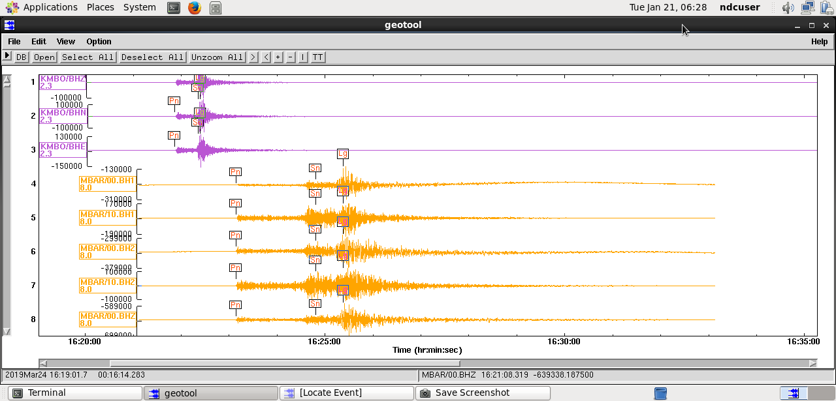
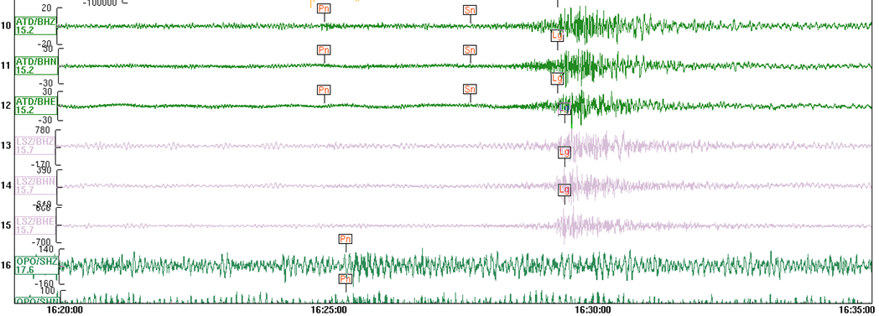

Figure 1. Seismic phases picked on seismograms for KMBO, MBAR, ATD, LSZ and OPO seismic stations for the 20190324 event.

Table 1. Coordinates, date, origin time (UTC), focal depth, magnitude, number seismic stations used in analysis and location area of the Chyulu hills seismic event.

Latitude | Longitude | Date and Origin time (UTC) | Depth (km) | Magnitude  ml mb | Number of seismic stations | Epicentral location
-3.0807º | 38.3428º | 20190324 16:21:13 | 9.1 | 4.9 4.2 | 25 | Chyulu hills in SW Kenya

Figure 2 shows events and their associated azimuths and speedsdetected at the Infrasound station I32KE for a duration of one and half hours on the 20190324. The sixth detection (lower panel) corresponds to the Chyulu hills event. Figure 3 shows a spectrogram of the detection associated with the Chyulu hills event at one of the sites (array element I32H1) at Infrasound station I32KE. The frequency content of the signal due to the Chyulu hills event ranges between 0-9 Hz suggesting an acoustic signal.
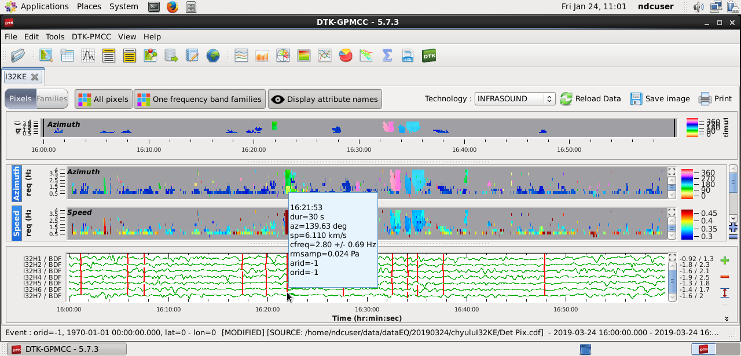
Figure 2. Pixels of events (red lines) and their associated azimuths, speeds and waveforms detected at I32KE infrasound station.

Figure 3: Spectrogram of the seismic event detection for array site I32H1 at the Infrasound station I32KE.

4. Discussion

Analysis of waveform data from twenty-five seismic and one-infrasound stations was undertaken in order to characterize the March 24, 2019 event. Based on the results presented in figure 2 and the summary of the results from seismic waveform analysis in table 1, the March 24, 2019 Chyulu hills event corresponds to the sixth detection in figure 2. The arrival time of this event at the infrasound station (16:21:53 UTC) closely corresponds to the arrival time of the Pn seismic phase (16:21:52 UTC) at KMBO seismic station which the closest seismic station (D=2.2º or ≅ 244 km) to Chyulu hills event in Kenya. The velocity of propagation (V=6.110 km/s) of the infrasound (acoustic) wave is consistent with a propagation path through the earth’s interior as opposed to atmospheric propagation (V≅344 m/s). The difference in arrival times of the infrasound (acoustic) and seismic waves is attributed to the difference in distances from the source to the respective seismic and infrasound stations and hence the delay of about one (1) secs in arrival of the acoustic signal to the infrasound station. The infrasound station to source azimuth of 139.63º(from figure 2) coincides with the direction of the epicentral location of the Chyulu hills event determined using seismic waveform data. Figure 4 shows the locations of the epicenter of the March 24, 2019 event as well as the infrasound (I32KE) and seismic (KMBO) stations in Kenya.

Figure 4. Locations of Infrasound (I32KE)and Seismic (KMBO) stations and the epicenter of the March 24, 2019 Chyulu hills event.

Conclusion

The March 24, 2019 event was detected by the infrasound and seismic stations in Kenya as well as by other seismic stations worldwide. Seismic waveforms for seismic stations closest to this event are characterized by the Lg surface wave phase indicative of a shallow event, which is likely to be man-made (anthropogenic) or natural. The depth of focus (focal depth), however, indicates a natural event at a depth of 9.1 km. The epicentral location of the event at 3.0807ºS and 38.3428ºE in the southwestern Kenya around Chyulu hills area coincides with the direction of the infrasound station to source azimuth of 139.63º. Infrasound and seismic technologies are therefore complementary in the location and characterization events in order to fulfil the objective and mandate of the Comprehensive Nuclear Test-Ban Treaty (CTBT) and ensuring nuclear testing and non-proliferation free world, hence promoting peace.
References

[1.] CTBTO Prep Comm. (1996)Comprehensive Nuclear Test-Ban Treaty (CTBT). Vienna, Austria: Author.

[2.] CTBTO Prep Comm. (2015)Guidebook for IDC Users on IMS data, IDC Products and technical assistance available to States Signatories. Vienna, Austria: Author.

[3.] Shearer, P.M. (2009) Introduction to seismology. Cambridge, Cambridge University Press.

[4.] Adams, R.D. and Marza, V.I. (1993) Crustal phases in earthquake location. Journal of Pure and Applied Geophysics, 140(1), 1-14.

[5.] Kulhanek, O. (1990) Anatomy of seismograms: Developments in solid earth geophysics 18. Amsterdam, Elsevier, 212 pp.

